

**Course Name:** APPLIED PHYSICS LAB

**Course ID:** GSL 113

**Instructor Name:** SIKANDAR HAYAT

**PROJECT: DAY LIGHT SENSOR**

**Submitted by:**

Syed Rayyan Shah Bokhari (01-134241-044)

Umm-e-Habiba-Imran (01-134241-048)

Zainab Idrees (01-134241-051)

Kashf Noor Zaheer Ahmed (01-134241-052)

**Project Report - Day Light Sensor Circuit**

**Introduction**

The Day Light Sensor Circuit is a practical project designed to illustrate the principles of light-dependent resistors (LDRs) and NPN transistors. This circuit detects the absence of light and activates an LED, simulating the behavior of automatic lighting systems. The project aims to provide a hands-on experience with basic electronic components and demonstrate the concept of light-sensitive switching.

**Objectives**

* To understand the working principle of a light-dependent resistor (LDR).
* To learn the basic operation of an NPN transistor.
* To construct a functional light-sensitive circuit.
* To demonstrate the practical application of these components in everyday electronic devices.

**LINKS**

[LinkedIn Link](https://www.linkedin.com/posts/activity-7203704745096589313-H-oe?utm_source=share&utm_medium=member_android)

**Project Methodology**

The methodology involved in this project includes the selection of appropriate components, circuit design, assembly on a breadboard, and systematic testing to ensure proper functionality.

* **Components Used**
* **2N3904 NPN Transistor:** Acts as a switch in the circuit.
* **Photoresistor (LDR):** Senses the light intensity and varies its resistance accordingly.
* **2K Ω Resistor:** Controls the base current of the transistor.
* **100 Ω Resistor:** Limits the current through the LED.
* **Bright LED:** Indicates the presence or absence of light.
* **4 AA Batteries:** Provide the power supply for the circuit.
* **Small Wire, Breadboard, Connecting Wires:** Used for assembling the circuit.
* **Circuit Assembly**

1. **Power Supply Connection:** The 4 AA batteries were connected to the breadboard power rails.
2. **Transistor Placement:** The 2N3904 transistor was inserted into the breadboard.
3. **LDR and Resistor Configuration:** The LDR was connected to the positive rail and to the base of the transistor via a 2K Ω resistor.
4. **LED Connection:** A 100 Ω resistor was connected between the collector of the transistor and the anode of the LED, while the cathode of the LED was connected to the negative rail.
5. **Emitter Connection:** The emitter of the transistor was directly connected to the negative rail.

* **Circuit Operation**

The LDR changes its resistance based on the light intensity. In bright light, the LDR’s resistance is low, preventing current from flowing through the transistor, keeping the LED off. In darkness, the LDR's resistance increases, allowing current to flow through the base of the transistor, turning it on and lighting the LED.

**Circuit Representation**

**Circuit Diagram**

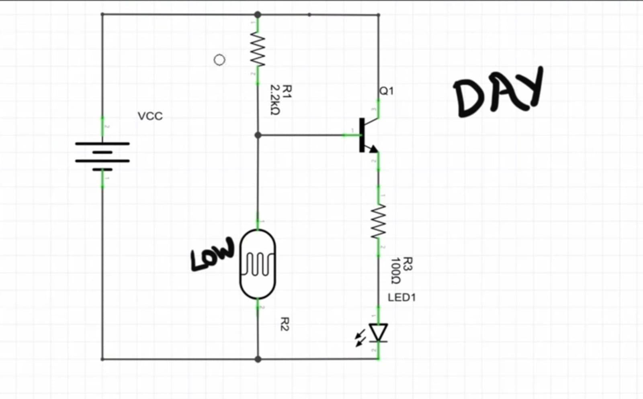

**Testing and Validation**

* **Testing Strategies**
* **Initial Power-Up:** Verified the power supply voltage and ensured all components were correctly placed on the breadboard.
* **Light Response Test:** Covered the LDR to simulate darkness and observed if the LED lights up. Exposed the LDR to light to see if the LED turns off.
* **Component Testing:** Checked individual components (transistor, LDR, resistors, LED) using a multimeter to ensure they function correctly.
* **Validation**

The circuit was validated by ensuring that the LED only lights up when the LDR is in darkness. Multiple tests were conducted by varying light conditions and ensuring consistent operation.

**Conclusion**

The Day Light Sensor Circuit project was successful in demonstrating the basic principles of light detection using an LDR and an NPN transistor. The circuit effectively showed how light intensity can control an electronic switch, which is fundamental in many real-world applications such as automatic street lights and night lamps.

* **Challenges Faced**
* **Stable Connections:** Ensuring all components were securely connected on the breadboard was challenging.
* **Component Sensitivity:** The sensitivity of the LDR required precise adjustment.
* **Future Enhancements**
* **Enhanced Sensitivity:** Implementing a more sensitive LDR for better light detection.
* **Delay Circuit:** Adding a delay circuit to prevent the LED from flickering due to rapid light changes.
* **Integration:** Integrating the circuit with microcontrollers for more advanced applications.

**References**

* "Basic Electronics for Scientists and Engineers" by Dennis L. Eggleston
* Datasheets for 2N3904 transistor and LDR from manufacturer websites
* Online electronics forums and tutorials for practical circuit building tips

**GitHub Link:**

**LinkedIn Video:**

---------------------************-----------------------